Exodus –
A People Moving Forward Together in Hope:
Leaders’ Guide
The Exodus journey did not just happen. The Book of Exodus gives us quite a bit of the background to it and to the chief characters.
The material below is not intended to be used in full. Think of it more as a buffet in which you select the parts that would be most helpful to your group or community. There is enough material for four sessions linking an extract from the Book of Exodus with the reflective questions that form part of the questionnaires for “Exploring the Way”. You could use parts of it for a whole parish day of reflection – or a couple of mornings/ evening sessions. You might also take pieces out to incorporate into other meetings to “tune-in” to the mix of prayer and data-gathering that will characterise phase two of Forward Together in Hope, Exploring the Way.
The four proposed sessions are listed below. If you are using this document on a computer, you can use Ctrl and click on the title to go directly to the relevant section.
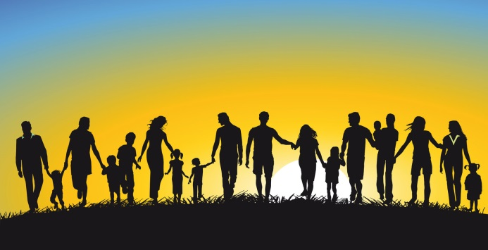
- Drawn from the Waters
Moses was drawn from the waters of the Nile and grew to fulfil a destiny God prepared for him. Baptism marks our entry into this great Story – giving us grace and responsibility for our Faith.
- Food for the Journey
The Exodus begins – with a meal.
- Challenges along the Way
The People of the Exodus faced challenges and choices – just as we do in our own Journey.
- Forming God’s People for the Future
God formed a people in a way of life and worship that was to mark them out as his People. The task continues…

Drawn from the Waters

Opening Responses
Reader We gather in the name of the Father:
All The eternal God of the past –
the present – and the future.
Reader We gather in the name of the Son:
All Who called together a people –
to bear his name
and to build his Kingdom.
Reader We gather in the name of the Holy Spirit:
All At work in the unfolding
of God’s mighty plan –
creating and renewing in every age
so that each generation
builds upon the richness of the last
and stands as firm foundation
for those to come.

Introduction (You might use – or just be aware of this extract from Exodus 1: 1-14)
A new king arose over Egypt, who did not know Joseph. He said to his people, ‘Look, the Israelite people are more numerous and more powerful than we. Come, let us deal shrewdly with them, or they will increase and, in the event of war, join our enemies and fight against us and escape from the land.’ Therefore they set taskmasters over them to oppress them with forced labour. They built supply cities, Pithom and Rameses, for Pharaoh. But the more they were oppressed, the more they multiplied and spread, so that the Egyptians came to dread the Israelites. The Egyptians became ruthless in imposing tasks on the Israelites, and made their lives bitter with hard service in mortar and brick and in every kind of field labour. They were ruthless in all the tasks that they imposed on them.)
Setting the Scene – Use these or your own words:
You might like to start by asking the group:
- Who has seen “Joseph and the Amazing Technicolor Dreamcoat?”
- What do you remember about it?
Things had started so well. Jacob and his sons had settled in Egypt after Joseph had saved them from the seven-year famine that had crippled Canaan’s food-stocks. Joseph had even been Pharaoh’s right hand man (vizier). But at the start of Exodus, several hundred years had passed and the Israelite or Hebrew people had increased in numbers. They had lost their status and were now mainly labourers and brick-makers but the Pharaoh had begun to fear that they might align themselves with his enemies.
After a “Golden Age”, life was getting tougher for the Israelites. They could look back on glory days but were faced with a very different world. The last few generations have seen big changes too – the world is very different from that of 25 – 50 – 100 years ago. It will be as different again in 25 – 50 – 100 years’ time. But God never abandons the world. In every generation, people are called to know him in a special way and to make him known.
We are among those people.
Before we go into the questions for Forward Together in Hope, we will look at the Scripture account of Moses’ being drawn from the waters – and the symbols of Baptism. This gives us a context for our reflections later.

Extract from Exodus
You could use (or tell the story from) Exodus about Moses being rescued from the waters:
The king of Egypt said to the Hebrew midwives, one of whom was named Shiphrah and the other Puah, ‘When you act as midwives to the Hebrew women, and see them on the birthstool, if it is a boy, kill him; but if it is a girl, she shall live.’ But the midwives feared God; they did not do as the king of Egypt commanded them, but they let the boys live. So the king of Egypt summoned the midwives and said to them, ‘Why have you done this, and allowed the boys to live?’ The midwives said to Pharaoh, ‘Because the Hebrew women are not like the Egyptian women; for they are vigorous and give birth before the midwife comes to them.’ So God dealt well with the midwives; and the people multiplied and became very strong. And because the midwives feared God, he gave them families. Then Pharaoh commanded all his people, ‘Every boy that is born to the Hebrews you shall throw into the Nile, but you shall let every girl live.’
Now a man from the house of Levi went and married a Levite woman. The woman conceived and bore a son; and when she saw that he was a fine baby, she hid him for three months. When she could hide him no longer she got a papyrus basket for him, and plastered it with bitumen and pitch; she put the child in it and placed it among the reeds on the bank of the river. His sister stood at a distance, to see what would happen to him.
The daughter of Pharaoh came down to bathe at the river, while her attendants walked beside the river. She saw the basket among the reeds and sent her maid to bring it. When she opened it, she saw the child. He was crying, and she took pity on him. ‘This must be one of the Hebrews’ children,’ she said. Then his sister said to Pharaoh’s daughter, ‘Shall I go and get you a nurse from the Hebrew women to nurse the child for you?’ Pharaoh’s daughter said to her, ‘Yes.’ So the girl went and called the child’s mother. Pharaoh’s daughter said to her, ‘Take this child and nurse it for me, and I will give you your wages.’ So the woman took the child and nursed it. When the child grew up, she brought him to Pharaoh’s daughter, and she took him as her son. She named him Moses, ‘because’, she said, ‘I drew him out of the water.’ (Exodus 1: 8-22)

Thoughts for Reflection
- What strikes you about the Reading?
The Vatican II document Gaudium et Spes (Joy and Hope) has the following sentence:
‘The future of humanity lies in the hands of those strong enough to give future generations reasons for living and for hoping.’
- How might the midwives—Moses’ family—and Pharaoh’s daughter be living examples of the people Gaudium et Spes describes?
- How might we be living examples of it?
Reflection on the Reading (optional)
There are all sorts of things we could look at in this – but for today, we might think of the quiet determination of the midwives and Moses’ mother and sister – even Pharaoh’s daughter defying her father – in the face of the attempts of Pharaoh to destroy their people. Despite their apparent lack of power, they believe in the future. Because of their actions, Moses was saved and grew up to be the person God chose to lead his people into that future. We will follow his story over the next few sessions.
Gaudium et Spes has the following quote which echoes this: “The future of humanity lies in the hands of those strong enough to give posterity reasons for living and for hoping.” These women were such people. In every generation, God calls forth ordinary people to do extraordinary things – not necessarily dramatic things but things which make a difference to the world. One such group are those who are called as disciples of Jesus Christ through their baptism.
In the early Church, baptism was seen as a huge step that brought with it, not just the promise of eternal life but the responsibility to share the Good News with others. It could be said that we have lost that sense of dignity and responsibility – not least because most of us did not choose to be baptised. However, the graces of baptism were poured over us – and with them came the power and the ability to use them.
Option
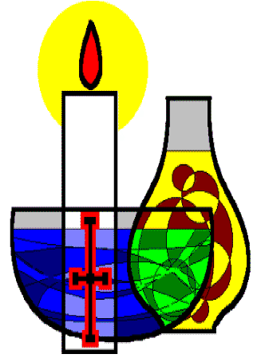
At this point you might like to invite the group to think about: Baptism – and its call for us today
Have the symbols used in baptism placed prominently.
When we are baptised, various symbols are used – water – light – white garment – oil.
Each marks a different aspect of the sacrament and its effect upon us. We will take each one in turn– spend time looking and listening to the words of the prayer that accompanies it. There will be time then for personal reflection and/or discussion about what this means for each of us and our call to move forward together in hope.
Read the prayers of baptism here…

Exploring the Way
Having reminded ourselves of the dignity and graces that come with baptism, we will now turn to some of the questions in Forward Together in Hope. The questions for this session come from the headings: The Christian Faithful and Leadership.
We will begin by looking at our community’s data which will give us information relevant to our reflective questions is presented to help our discussions.

Reflective Questions
- What lay leadership is currently available and effective in our community?

- For what other areas of our community life could carefully prepared lay men and women assume responsibility?

Allow as long as possible for people to discuss and reflect together and then take feedback – ensure that someone is on hand to note thoughts down or put on a flipchart so that everyone can see that their thoughts are recorded.

Closing Prayer
You might like to have a renewal of baptismal promises.
To culminate in all saying together:
This is our faith. This is the faith of the Church. We are proud to profess it, in Christ Jesus our Lord.
Close with the Forward Together in Hope prayer.
Glory be to the Father -
in whom we live and move
and have our being.

Glory be to the Son -
Whose name we bear
and who calls each of us
to be his disciples;
to build his Kingdom
and to go out into the world
and bear its fruit.

Glory be to the Holy Spirit -
pouring out grace and guidance,
forming us and renewing us.

Inspire us all
In the Diocese of Hexham and Newcastle
to live the Gospel,
to be open to change
and to move forward together in hope...

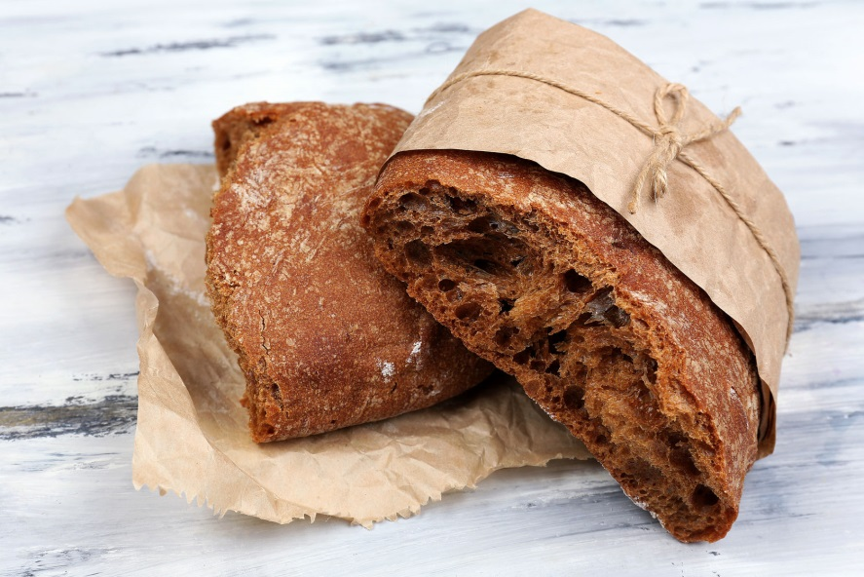
You might think about a focal point that includes bread and wine. The passage we will use in the session is the one used on Holy Thursday and some of our reflections on Forward Together in Hope will relate to the Mass.

Food for the Journey
Opening Responses
Reader We gather in the name of the Father:
All Who called to Moses
from a burning bush
and called him to lead his people
into the future
he was preparing for them.
Reader We gather in the name of the Son:
All Who celebrated Passover
with his family and friends
and used its mix of sacrifice and meal
to give us the Eucharist.
Reader We gather in the name of the Holy Spirit:
All Who gives vision and courage
to the People of God
as they respond to God’s call
to the Table of the Eucharist
and to take his grace into the world.

Extract from Exodus
Use these or your own words:
We have skipped the sections in Exodus about God calling to Moses from the burning bush and the first nine plagues that beset the people. All of them – apart from the deaths of the first-born – were suffered by Egyptian and Israelite alike so everyone was more than ready when Pharaoh decided to let God’s people go. We pick up the story at that point using extracts from Chapter 12 of Exodus. You will recognise parts of it from the Mass of the Lord’s Supper on Holy Thursday – when we also recall Jesus instituting the Eucharist.
Note: the reading is quite long so we have suggested some thoughts for people to ponder on briefly at various points. It can also help to have a picture for people to look at – printed out or on a screen or a wall. Ask them to make a mental note of anything that strikes them as they listen – a word or phrase or particular incident.
The Lord said to Moses and Aaron in the land of Egypt: This month shall mark for you the beginning of months; it shall be the first month of the year for you. Tell the whole congregation of Israel that on the tenth of this month they are to take a lamb for each family, a lamb for each household. If a household is too small for a whole lamb, it shall join its closest neighbour in obtaining one; the lamb shall be divided in proportion to the number of people who eat of it. Your lamb shall be without blemish, a year-old male; you may take it from the sheep or from the goats. You shall keep it until the fourteenth day of this month; then the whole assembled congregation of Israel shall slaughter it at twilight. They shall take some of the blood and put it on the two doorposts and the lintel of the houses in which they eat it.
This is how you shall eat it: your loins girded, your sandals on your feet, and your staff in your hand; and you shall eat it hurriedly. It is the passover of the Lord. For I will pass through the land of Egypt that night, and I will strike down every firstborn in the land of Egypt, both human beings and animals; on all the gods of Egypt I will execute judgements: I am the Lord. The blood shall be a sign for you on the houses where you live: when I see the blood, I will pass over you, and no plague shall destroy you when I strike the land of Egypt.
At midnight the Lord struck down all the firstborn in the land of Egypt, from the firstborn of Pharaoh who sat on his throne to the firstborn of the prisoner who was in the dungeon, and all the firstborn of the livestock.
- What do you make of this part of the account? Don’t think too much about a “right” answer – just your reaction. You might like to think about – the importance of the meal – the part sacrifice plays – the idea of justice or vengeance…
Pharaoh arose in the night, he and all his officials and all the Egyptians; and there was a loud cry in Egypt, for there was not a house without someone dead. Then he summoned Moses and Aaron in the night, and said, ‘Rise up, go away from my people, both you and the Israelites! Go, worship the Lord, as you said. Take your flocks and your herds, as you said, and be gone. And bring a blessing on me too!’
The Egyptians urged the people to hasten their departure from the land, for they said, ‘We shall all be dead.’ So the people took their dough before it was leavened, with their kneading-bowls wrapped up in their cloaks on their shoulders. The Israelites had done as Moses told them; they had asked the Egyptians for jewellery of silver and gold, and for clothing, and the Lord had given the people favour in the sight of the Egyptians, so that they let them have what they asked.
The Israelites journeyed from Rameses to Succoth, about six hundred thousand men on foot, besides children. A mixed crowd also went up with them, and livestock in great numbers, both flocks and herds. They baked unleavened cakes of the dough that they had brought out of Egypt; it was not leavened, because they were driven out of Egypt and could not wait, nor had they prepared any provisions for themselves.
- What strikes you from this part of the account? The reaction of Pharaoh and the Egyptians? Or the “mixed crowd” –made up of all kinds of people? Or the fact that it came on them suddenly – even though Moses and Aaron had told them the day was coming? Or…?
Invite people to share their first reactions to the story in twos and threes.

Exploring the Way
Our reading has described a meal – a mixed crowd of people taking on various roles to get the people ready for the journey… or not getting ready for the journey! It takes a lot to get people to think about moving forward or changing – and many were unprepared. But enough were and had the wherewithal to share and survive what was to come.
Our questions for reflection from Forward Together in Hope come from the sections on Active Participation of People and Worship and Spiritual Life.
We will begin by looking at the data for our community related to these sections.

Reflective Questions
- How diverse and active are parishioners within our community?
- How can we invite and prepare more people to support our community?
- Are there aspects of our regular worship together at Mass that are working particularly well and which deepen the spiritual life of those present?
- Is there anything we can do to encourage a deeper prayer life and more engagement with Scripture?

Allow as long as possible for people to discuss and reflect together and then take feedback – ensure that someone is on hand to note thoughts down or put on a flipchart so that everyone can see that their thoughts are recorded.

Closing Prayer
Glory be to the Father -
in whom we live and move
and have our being.

Glory be to the Son -
Whose name we bear
and who calls each of us
to be his disciples;
to build his Kingdom
and to go out into the world
and bear its fruit.

Glory be to the Holy Spirit -
pouring out grace and guidance,
forming us and renewing us.

Inspire us all
In the Diocese of Hexham and Newcastle
to live the Gospel,
to be open to change
and to move forward together in hope...

Opening Responses

Challenges along the Way

Reader We gather in the name of the Father:
All Who lays before his People a journey –
that will challenge and stretch them
but will help them to grow into
the people he longs for them to be.

Reader We gather in the name of the Son:
All Who led his early disciples
on a journey of discovery –
and who continues to call disciples
to continue the quest of building
the Kingdom of God.

Reader We gather in the name of the Holy Spirit:
All Who works in the minds and hearts
of men and women –
gifting them with skills and strength
to overcome the challenges
before them
and the love to do all
for the glory of God.

Extract from Exodus
Last time, we saw the beginning of the journey that God led his people on. They were a mixed crowd – young and old, strong and weak, those with training and skills in living off the land – others more comfortable with town-living.
Although they lived several thousand years ago, put into modern dress and brought into our churches they would probably look pretty much like us! We are fortunate that God has not returned the compliment and taken us into a physical wilderness for our Journey Forward Together in Hope – though it may feel equally daunting at times.
Our readings this week are a series of snippets from the journey of the Hebrews – little incidents that speak of the challenges they faced. An account of the Exodus is also told in the Book of Numbers – one of the extracts are taken from there. (Note to leader – you might think about sharing out the readings – give them out at the beginning to allow people time to read them through beforehand).
We will pause between each one to give time for some reflection.

The whole congregation of the Israelites complained against Moses and Aaron in the wilderness. The Israelites said to them, ‘If only we had died by the hand of the Lord in the land of Egypt, when we sat by the fleshpots and ate our fill of bread; for you have brought us out into this wilderness to kill this whole assembly with hunger.’
Then the Lord said to Moses, ‘I am going to rain bread from heaven for you, and each day the people shall go out and gather enough for that day. In that way I will test them, whether they will follow my instruction or not. On the sixth day, when they prepare what they bring in, it will be twice as much as they gather on other days.’ So Moses and Aaron said to all the Israelites, ‘In the evening you shall know that it was the Lord who brought you out of the land of Egypt, and in the morning you shall see the glory of the Lord, because he has heard your complaining against the Lord. For what are we, that you complain against us?’ (Exodus 16: 2-7)
- How much sympathy do you have for the Israelites?
- What do you think about how God responded?
The Israelites wept again, and said, ‘If only we had meat to eat! We remember the fish we used to eat in Egypt for nothing, the cucumbers, the melons, the leeks, the onions, and the garlic; but now our strength is dried up, and there is nothing at all but this manna to look at.’ (Numbers 11: 4-6)
- How does the hankering back to the good times reflect how people might feel – perhaps quite legitimately – in your community?
When the people saw that Moses delayed to come down from the mountain, the people gathered around Aaron and said to him, ‘Come, make gods for us, who shall go before us; as for this Moses, the man who brought us up out of the land of Egypt, we do not know what has become of him.’ Aaron said to them, ‘Take off the gold rings that are on the ears of your wives, your sons, and your daughters, and bring them to me.’ So all the people took off the gold rings from their ears, and brought them to Aaron. He took the gold from them, formed it in a mould, and cast an image of a calf; and they said, ‘These are your gods, O Israel, who brought you up out of the land of Egypt!’ (Exodus 32: 1-4)
- This is clearly a “false god” taking the place of the one, true God. But when are we also tempted to see things – even holy things – as more important than God?
The people quarrelled with Moses, and said, ‘Give us water to drink.’ Moses said to them, ‘Why do you quarrel with me? Why do you test the Lord?’ But the people thirsted there for water; and the people complained against Moses and said, ‘Why did you bring us out of Egypt, to kill us and our children and livestock with thirst?’ So Moses cried out to the Lord, ‘What shall I do with this people? They are almost ready to stone me.’ The Lord said to Moses, ‘Go on ahead of the people, and take some of the elders of Israel with you; take in your hand the staff with which you struck the Nile, and go. I will be standing there in front of you on the rock at Horeb. Strike the rock, and water will come out of it, so that the people may drink.’ Moses did so, in the sight of the elders of Israel. He called the place Massah and Meribah, because the Israelites quarrelled and tested the Lord, saying, ‘Is the Lord among us or not?’ (Exodus 16: 2-7)
- A time for honesty! How often do you think your parish priest – deacon – Sister – pastoral council and finance committee feel like Moses?
- Have you ever felt like it? (Not necessarily in a church setting but that is our focus today).
Invite people to share their first reactions to the story in twos and threes.

Exploring the Way
The questions for reflection today come from three sections – Finance and Facilities (how we use the resources given to us) and Geographical Distance.
We will begin by looking at the relevant data for our community.
- How do you feel about the average weekly offertory donation in our community? Will it be sustained until 2030?
- If you are a finance-rich community, how do you feel about sharing some of your resources with very poor parts of the diocese?
- What sort of use can you foresee for unused or underused facilities in our community in the future?
- How can the community develop the capacity to look after them?
- How do you feel if the only way to ensure a flourishing community is to become part of a new parish community?
- How might our community serve and support neighbouring communities?
Allow as long as possible for people to discuss and reflect together and then take feedback – ensure that someone is on hand to note thoughts down or put on a flipchart so that everyone can see that their thoughts are recorded.

Closing Prayer
Glory be to the Father -
in whom we live and move
and have our being.

Glory be to the Son -
Whose name we bear
and who calls each of us
to be his disciples;
to build his Kingdom
and to go out into the world
and bear its fruit.

Glory be to the Holy Spirit -
pouring out grace and guidance,
forming us and renewing us.

Inspire us all
in the Diocese of Hexham and Newcastle
to live the Gospel,
to be open to change
and to move forward together in hope.

Forming God’s People for the Future

Opening Responses
Reader We gather in the name of the Father:
All Who has a dream for humanity
and for all Creation
and entrusts this
to mere men and women
to bring to fulfilment.

Reader We gather in the name of the Son:
All Who teaches his disciples
through word and action
and commissioned them
to pass on to others
all that they have learned from him.

Reader We gather in the name of the Holy Spirit:
All Who gives wisdom, knowledge and understanding to God’s people
so that in a world
of change and uncertainty,
they can discern the will of God
and follow it.

Extract from Exodus
We come towards the end of the Book of Exodus and will look today at how God, Moses and Aaron prepare the People for the Promised Land.

We will use a few extracts with pauses for thought in between.
God spoke all these words:
I am the Lord your God, who brought you out of the land of Egypt, out of the house of slavery; you shall have no other gods before me.
You shall not make for yourself an idol, whether in the form of anything that is in heaven above, or that is on the earth beneath, or that is in the water under the earth. You shall not bow down to them or worship them; for I the Lord your God am a jealous God, punishing children for the iniquity of parents, to the third and the fourth generation of those who reject me, but showing steadfast love to the thousandth generation of those who love me and keep my commandments.
You shall not make wrongful use of the name of the Lord your God, for the Lord will not acquit anyone who misuses his name.
Remember the sabbath day, and keep it holy. For six days you shall labour and do all your work. But the seventh day is a sabbath to the Lord your God; you shall not do any work—you, your son or your daughter, your male or female slave, your livestock, or the alien resident in your towns. For in six days the Lord made heaven and earth, the sea, and all that is in them, but rested the seventh day; therefore the Lord blessed the sabbath day and consecrated it.
Honour your father and your mother, so that your days may be long in the land that the Lord your God is giving you.
You shall not murder.
You shall not commit adultery.
You shall not steal.
You shall not bear false witness against your neighbour.
You shall not covet your neighbour’s house; you shall not covet your neighbour’s wife, or male or female slave, or ox, or donkey, or anything that belongs to your neighbour.
- The Ten Commandments are familiar – but what would a society look like where people did not do the things that God says they will not do?
I will meet the Israelites there, and it shall be sanctified by my glory; I will consecrate the tent of meeting and the altar; Aaron also and his sons I will consecrate, to serve me as priests. I will dwell among the Israelites, and I will be their God. And they shall know that I am the Lord their God, who brought them out of the land of Egypt that I might dwell among them; I am the Lord their God. (Exodus 29: 43-46)
- This actually follows a very long list of instructions about what the Ark of Covenant should be like – as well as how priests are to be ordained and vested. For our purposes, think about how we honour the God who dwells among us in our own day – and how we make him known to others.
The end of Moses’ story actually comes in Deuteronomy:
Then Moses went up from the plains of Moab to Mount Nebo, to the top of Pisgah, which is opposite Jericho, and the Lord showed him the whole land: Gilead as far as Dan, all Naphtali, the land of Ephraim and Manasseh, all the land of Judah as far as the Western Sea, the Negeb, and the Plain—that is, the valley of Jericho, the city of palm trees—as far as Zoar. The Lord said to him, ‘This is the land of which I swore to Abraham, to Isaac, and to Jacob, saying, “I will give it to your descendants”; I have let you see it with your eyes, but you shall not cross over there.’ Then Moses, the servant of the Lord, died there in the land of Moab, at the Lord’s command. He was buried in a valley in the land of Moab, opposite Bethpeor, but no one knows his burial place to this day. Moses was one hundred and twenty years old when he died; his sight was unimpaired and his vigour had not abated.
- Moses glimpsed the Promised Land but did not live to see it. It reminds us that we are sowing seeds for a future that does not belong to us either. How do you feel about working hard in your own lifetime for things that you will not see but which future generations will build on?
Invite people to share their first reactions to the story in twos and threes.

Exploring the Way
Our questions from Forward Together in Hope this time come from Education and Continuing Formation, Outreach and Young People.
We begin by looking at the data about these areas in our own community.

Reflective Questions
- What good experiences of ‘continuing formation’ in the faith have you had in the past?
- What opportunities would you support for ‘continuing formation ‘in the faith for members of the worshipping community?
- How can closer relationships be developed between the worshipping community, the school (if appropriate) and the families that belong to both?
- What good experiences have you had regarding our call to be involved with other Christians, other faiths, all men and women of good will?
- How can the worshipping community become more immersed in the local community?
- What good experiences regarding Church life do the young people have in your community?
- How can the presence and witness of young people be more encouraged and supported in the community?

Closing Prayer
If you have used the four sessions – or parts of them in a day of reflection, you might like to look back prayerfully over the meetings and some of the issues that have arisen.
Give thanks for the good things – and ask God’s grace for the things that look as if they will need attention.
Close with the Forward Together in Hope prayer.
Glory be to the Father -
in whom we live and move
and have our being.

Glory be to the Son -
Whose name we bear
and who calls each of us
to be his disciples;
to build his Kingdom
and to go out into the world
and bear its fruit.

Glory be to the Holy Spirit -
pouring out grace and guidance,
forming us and renewing us.

Inspire us all
In the Diocese of Hexham and Newcastle
to live the Gospel,
to be open to change
and to move forward together in hope...

When we hear the word “exodus”,
we immediately think of the origins of the amazing love story
between God and his people,
a history which passes through the dramatic period of slavery in Egypt,
the calling of Moses,
the experience of liberation and the journey toward the Promised Land.

The Book of Exodus, the second book of the Bible,
which recounts these events is a parable of the entire history of salvation
but also of the inner workings of Christian faith.

Passing from the slavery of the old Adam to new life in Christ
is an event of redemption which takes place through faith (Eph 4:22-24).
This passover is a genuine “exodus”;
it is the journey of each Christian soul and the entire Church,
the decisive turning of our lives towards the Father.
Pope Francis
Exodus, a fundamental experience of vocation.
Letter for Vocations Sunday 2015

